Class activity - CO5 JDBC Program

- To retrieve / view the data from back end

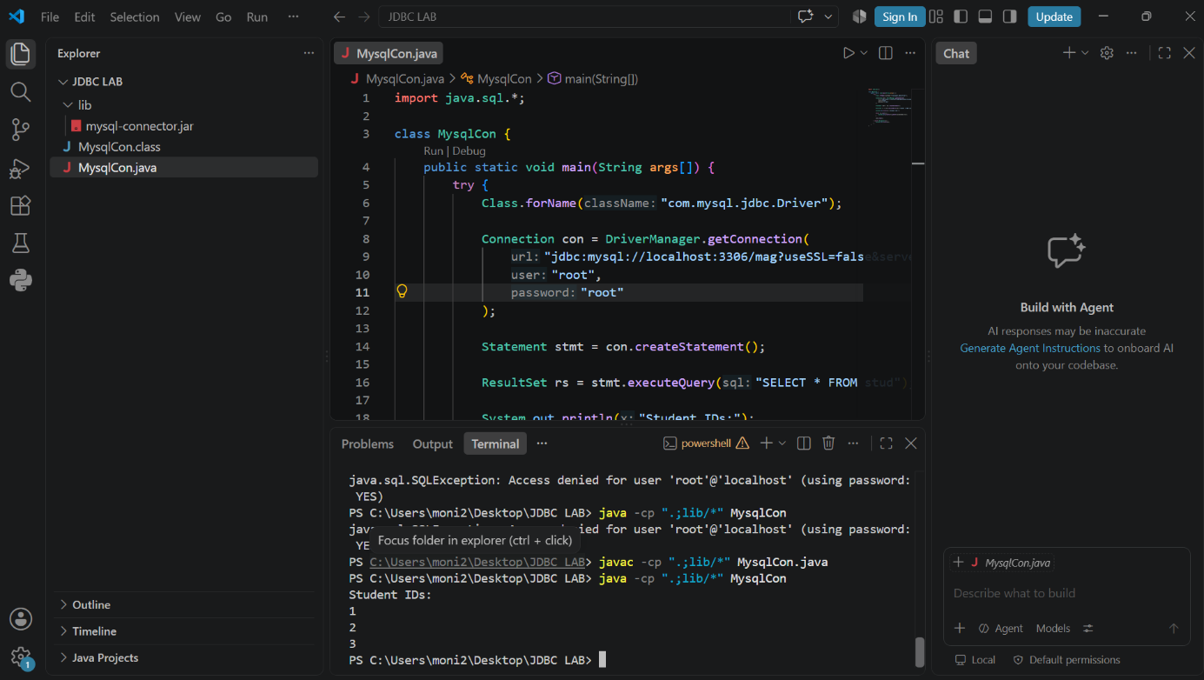

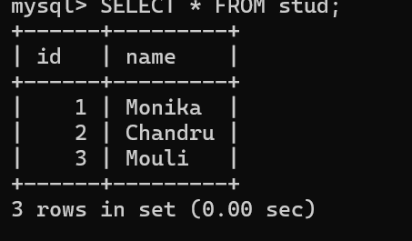

2. To update / retrieve the data from backend

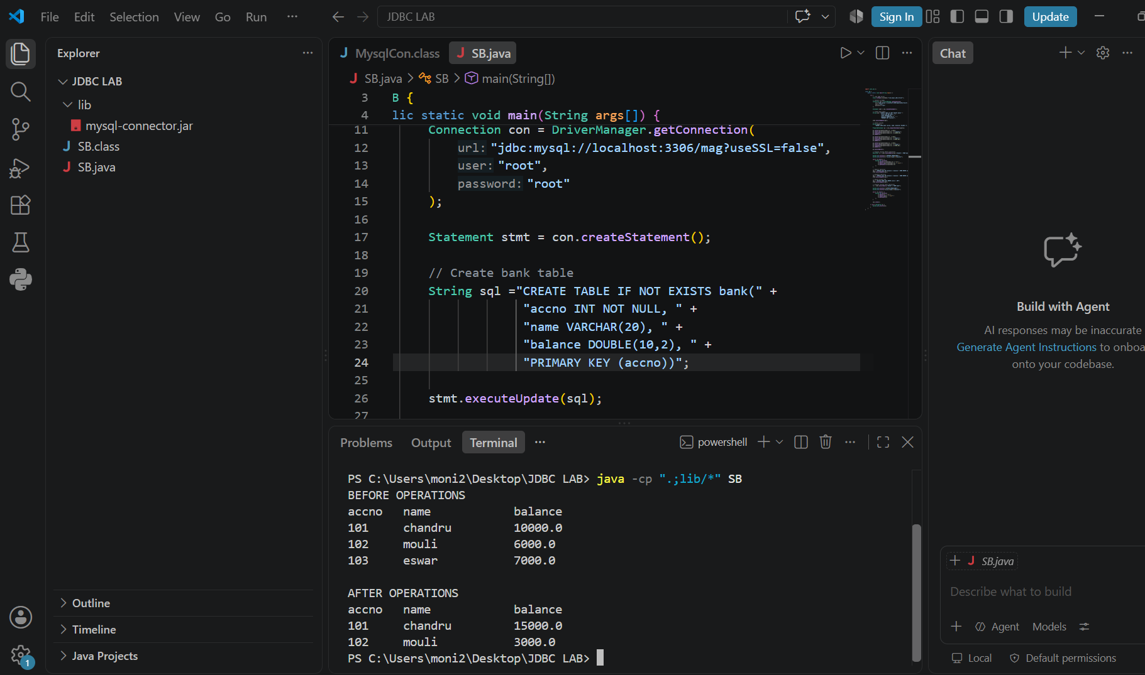

3. Using AWT, providing user interface and event handling
initiates user interaction with back end

